**CUSTOM BOOTCAMP ASSESSMENT**

**POWER BI**

-ANISHA GUPTA

EMP ID: 655517

Loading data in SQL Server:

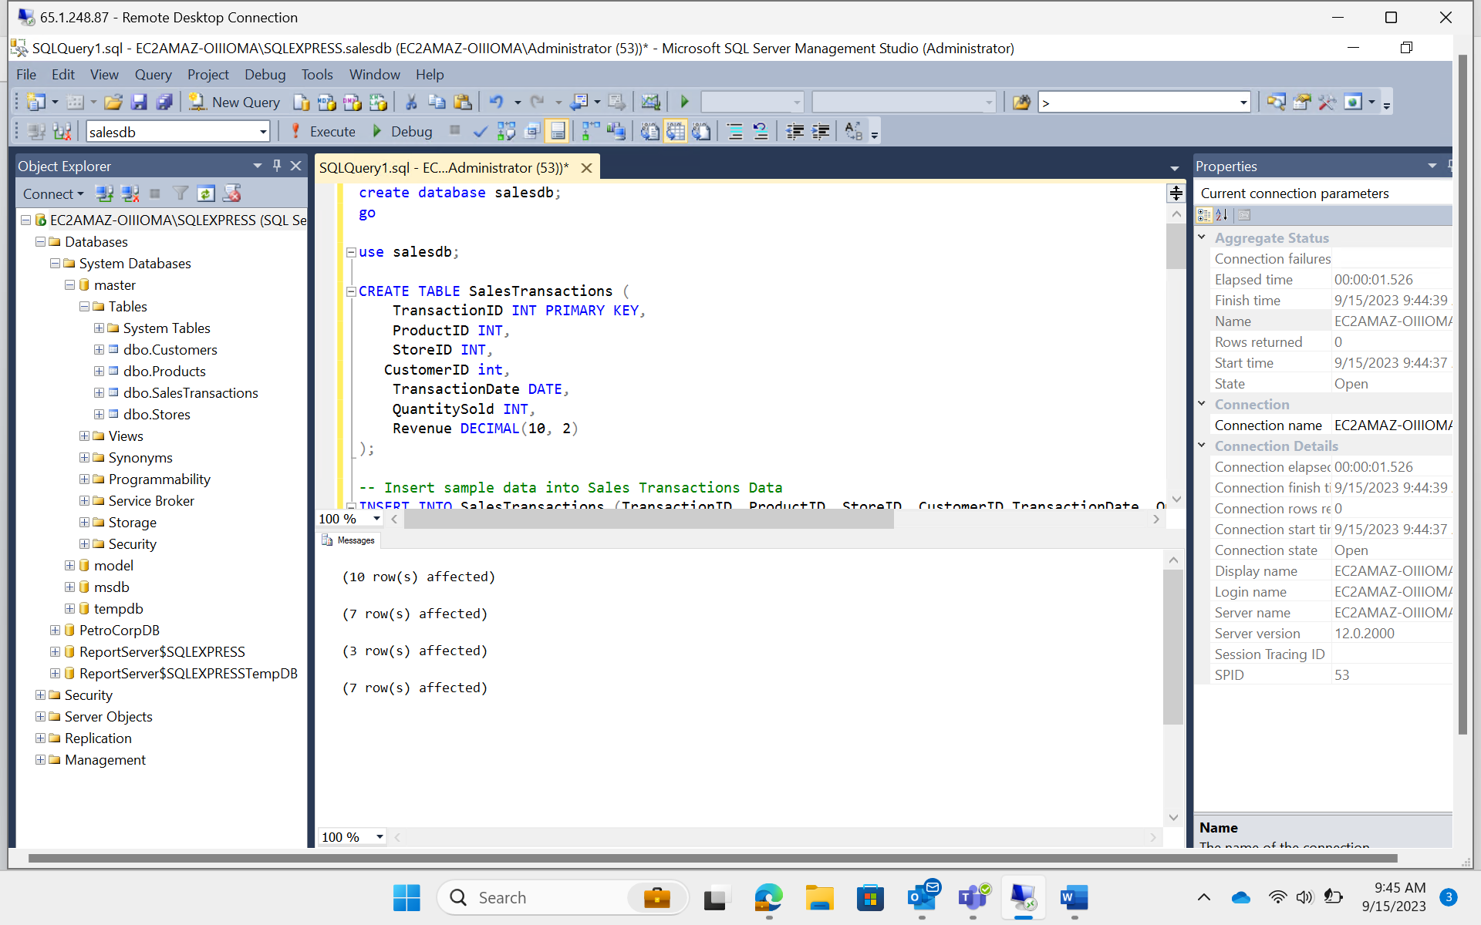

Loading data in PowerBI:

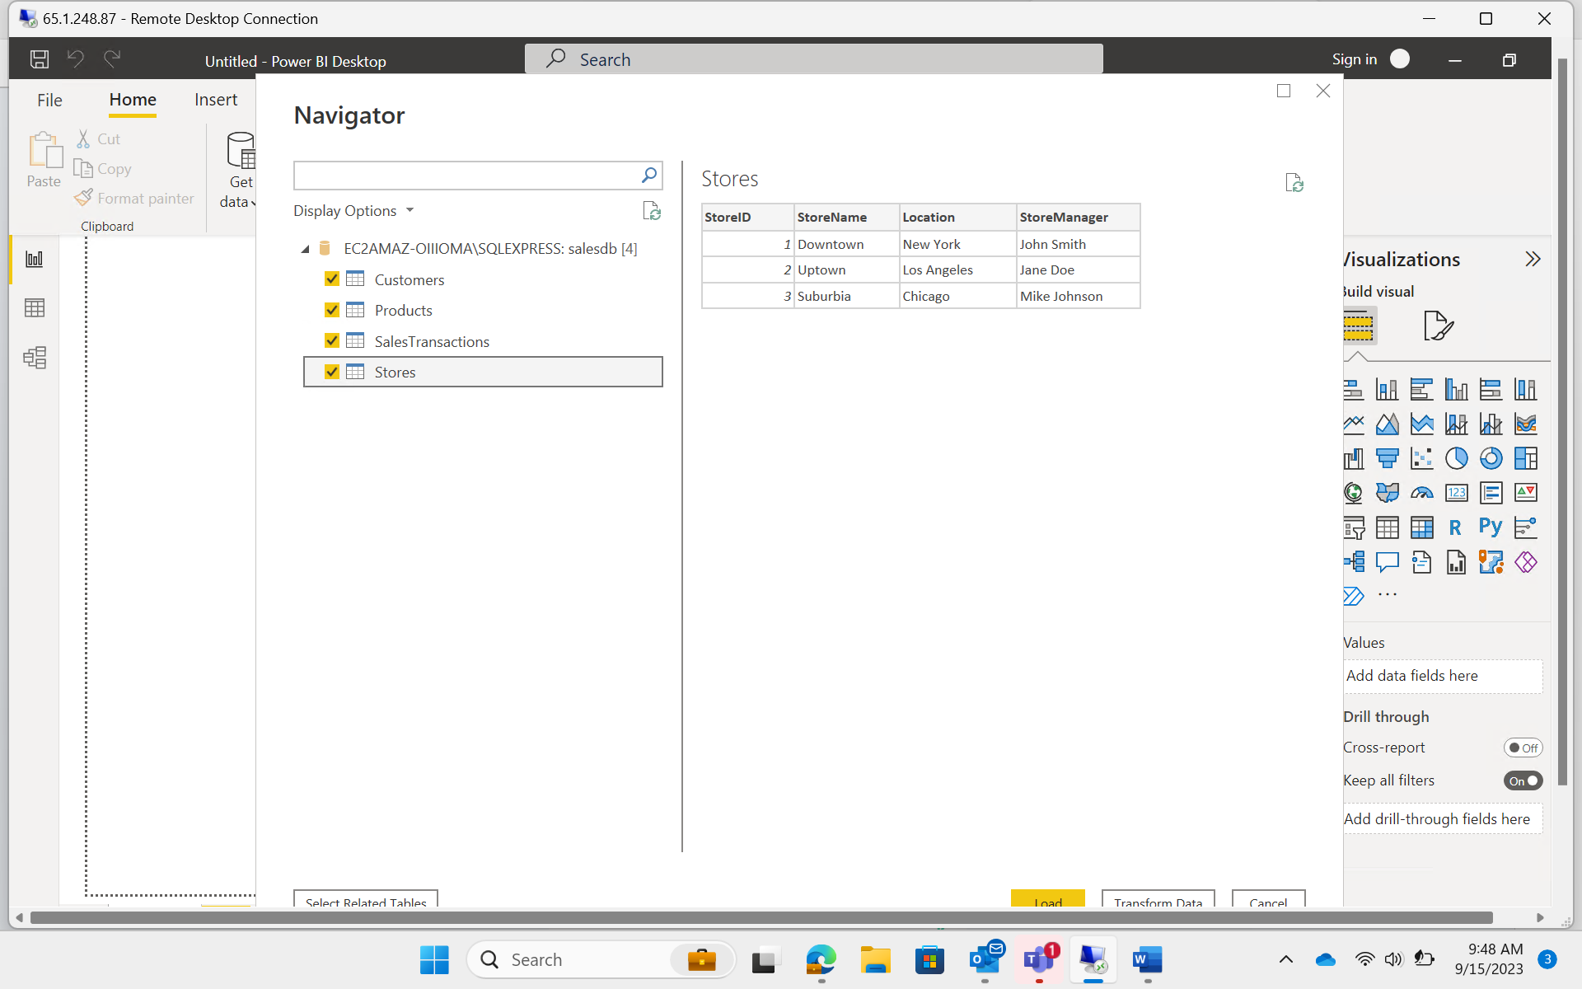

Data Loaded Successfully

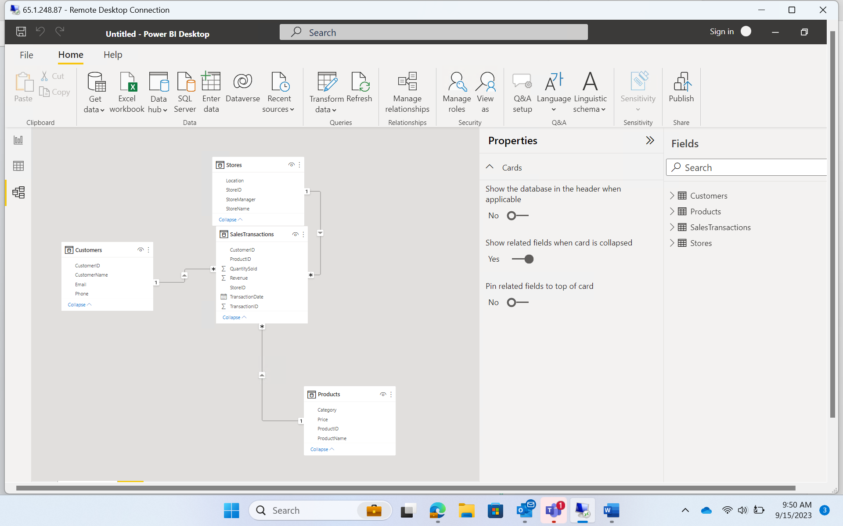

TRANSFORMING DATA:

Tables Joined:

Cleaning data and Filtering:

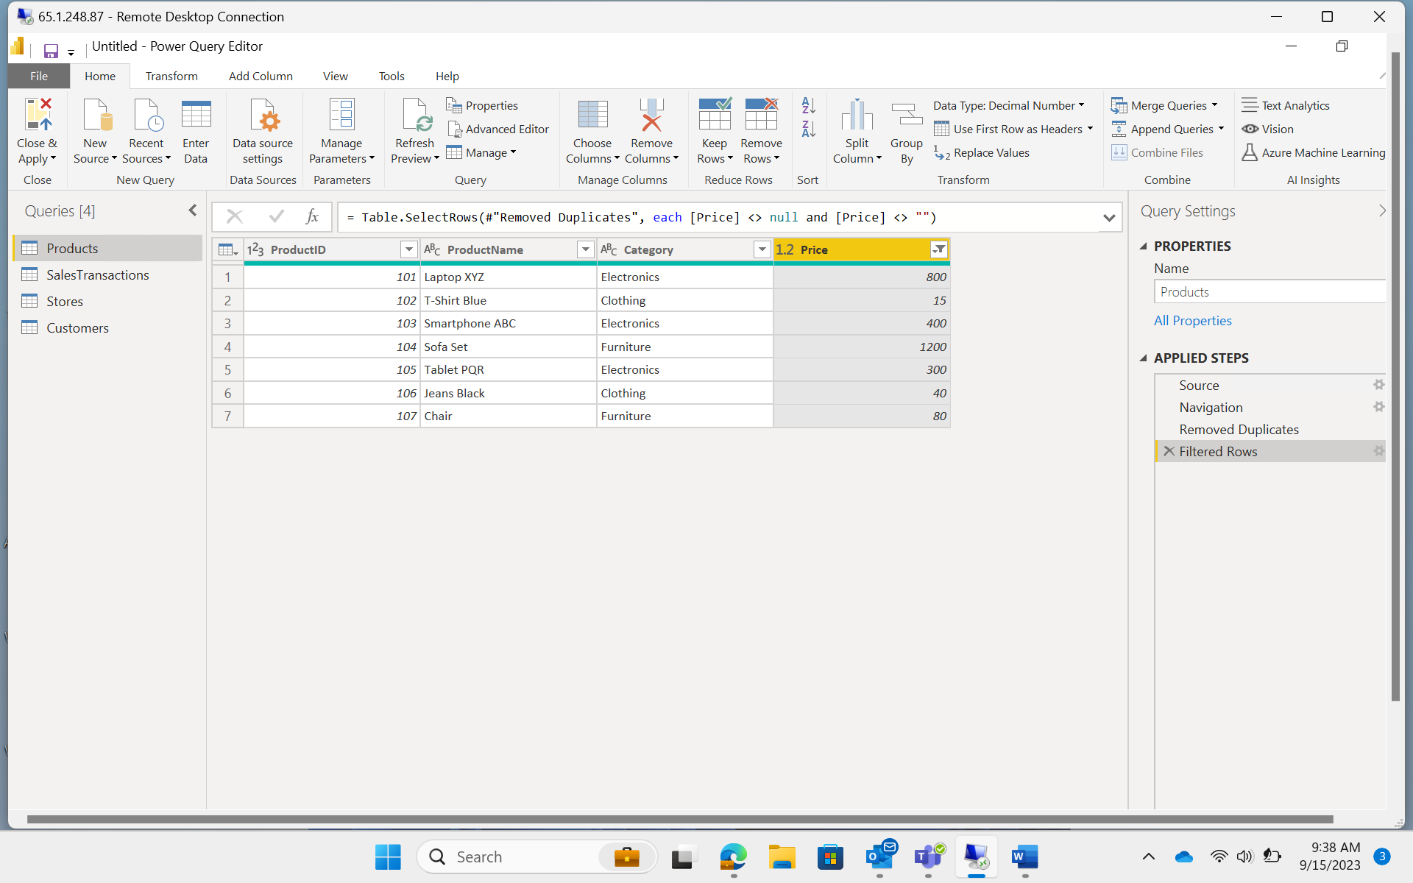

Calculated Column: Day of the week

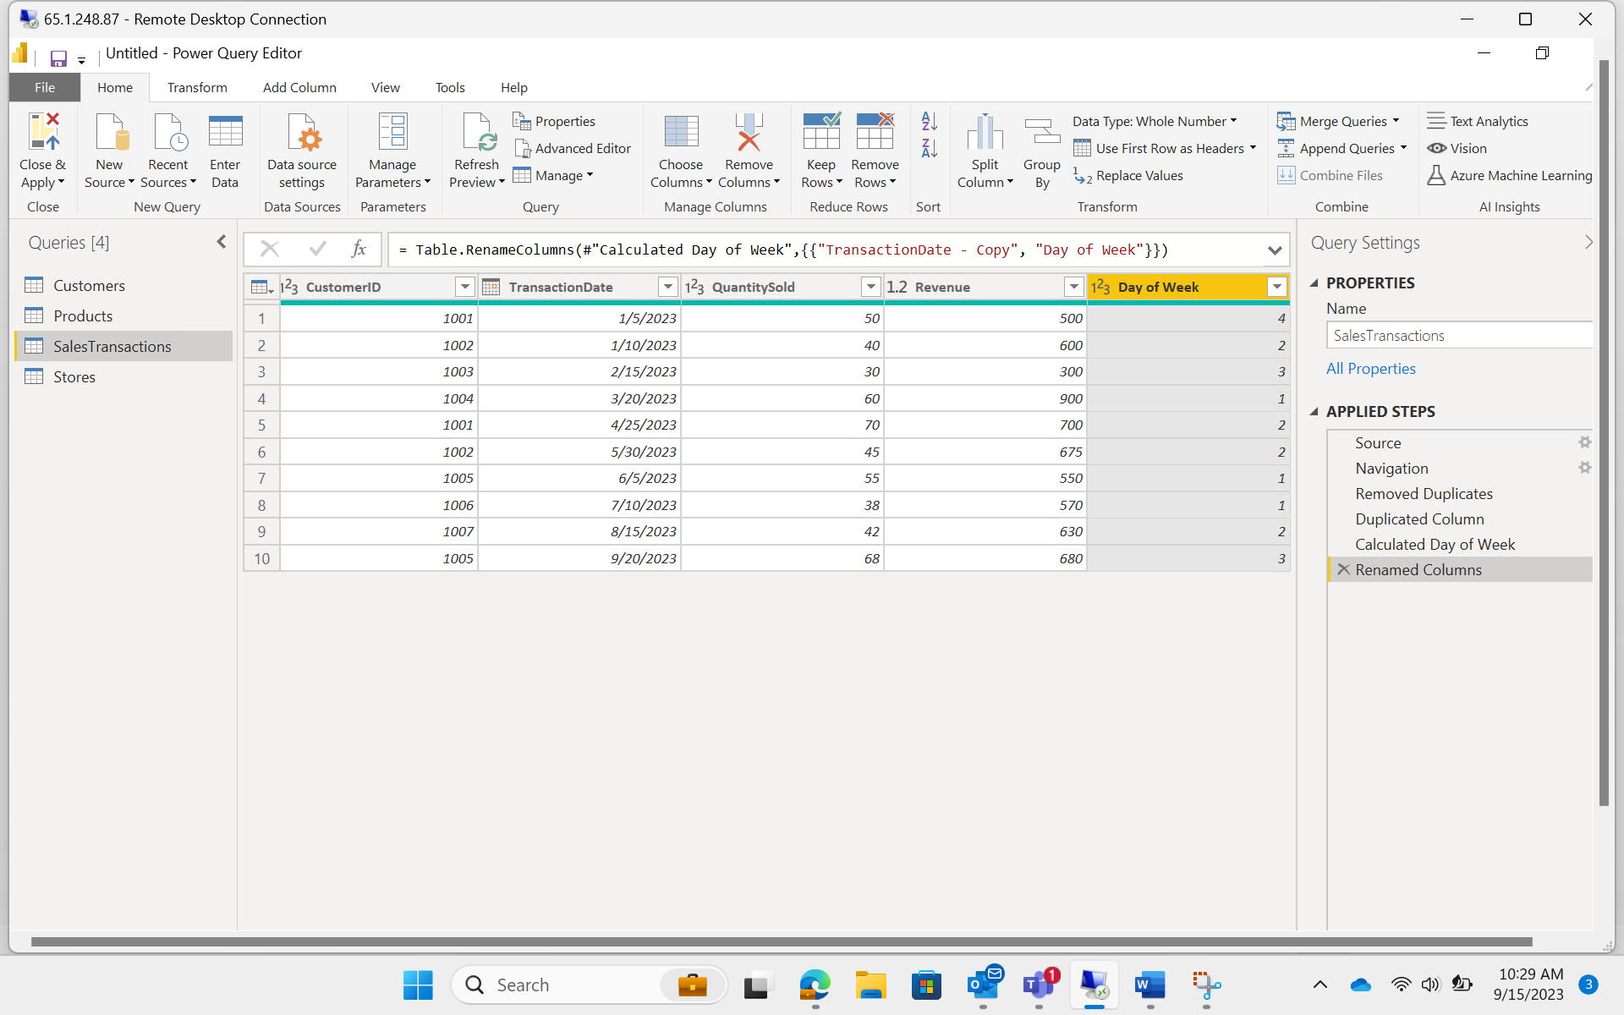

Adding filter on price:

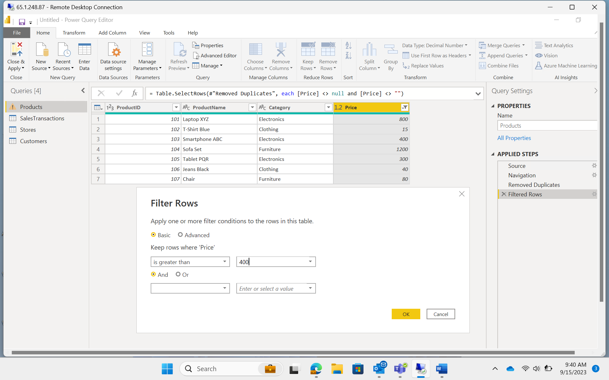

Sorted Rows according to date:

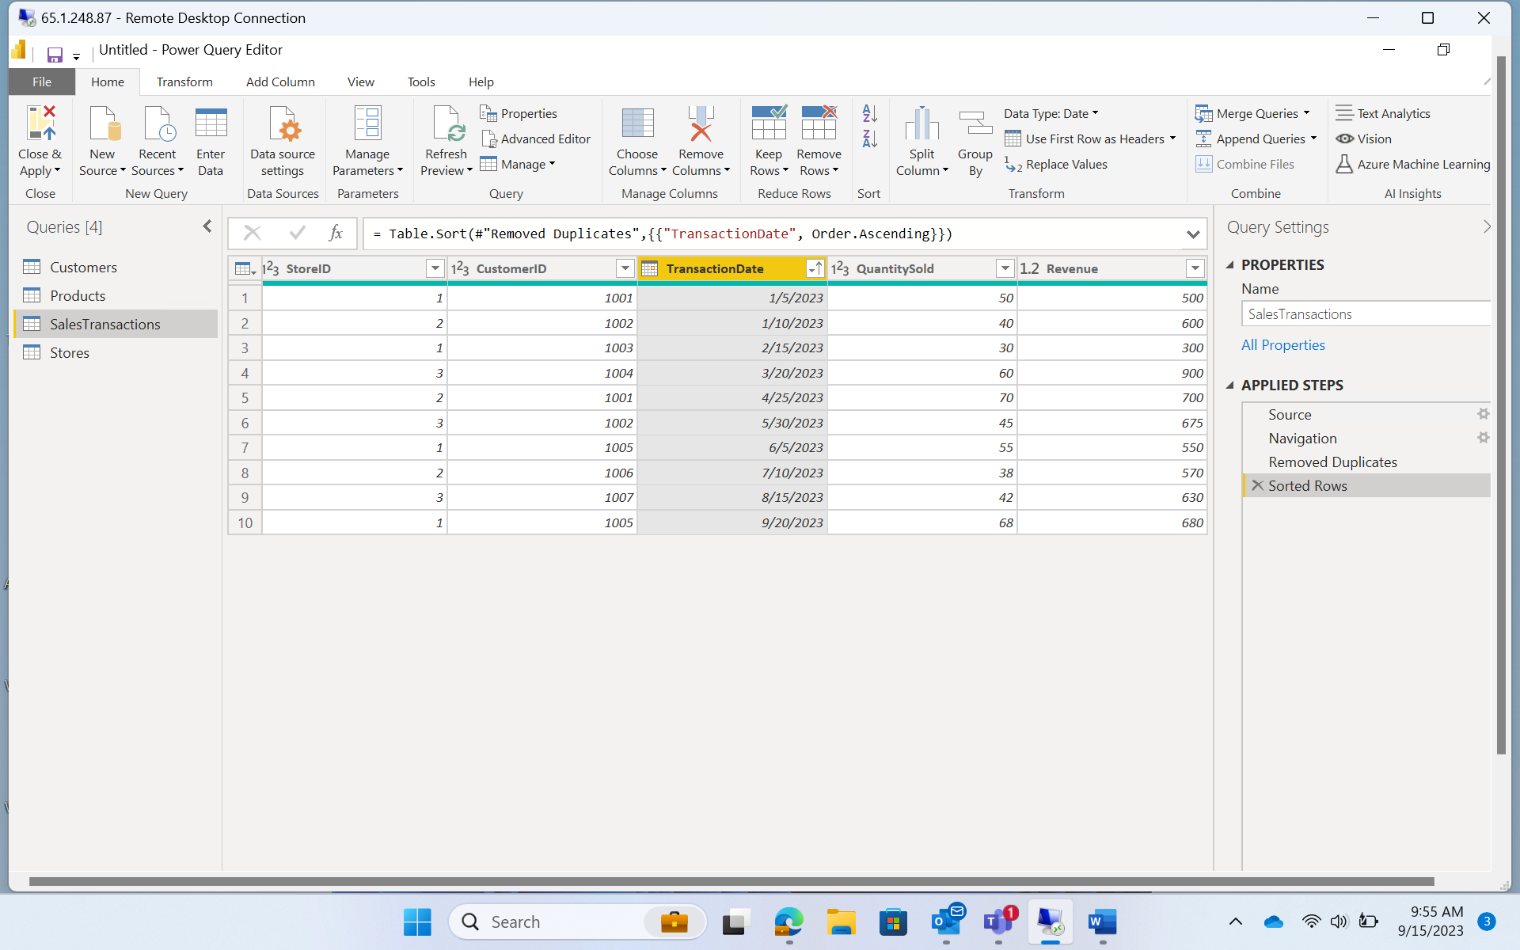

DATA MODELING:

Relationship:

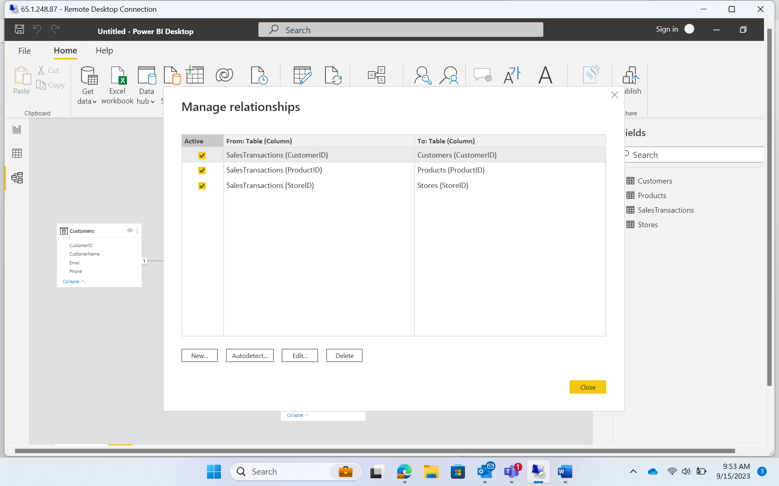

Hierarchy:

BUSINESS QUERIES AND ANALYSIS:

1. Who are the top-spending customers based on their total purchase amount?

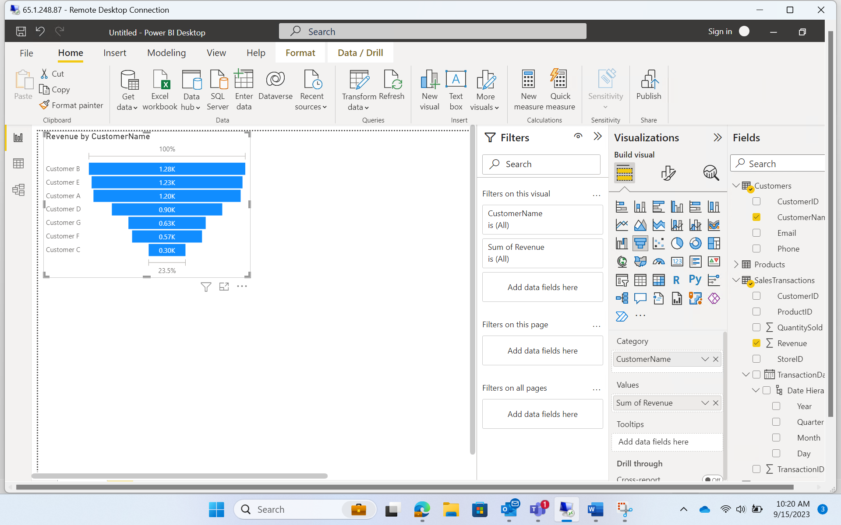

Customer B has the most spendings.

1. How is sales revenue distributed among different store managers?

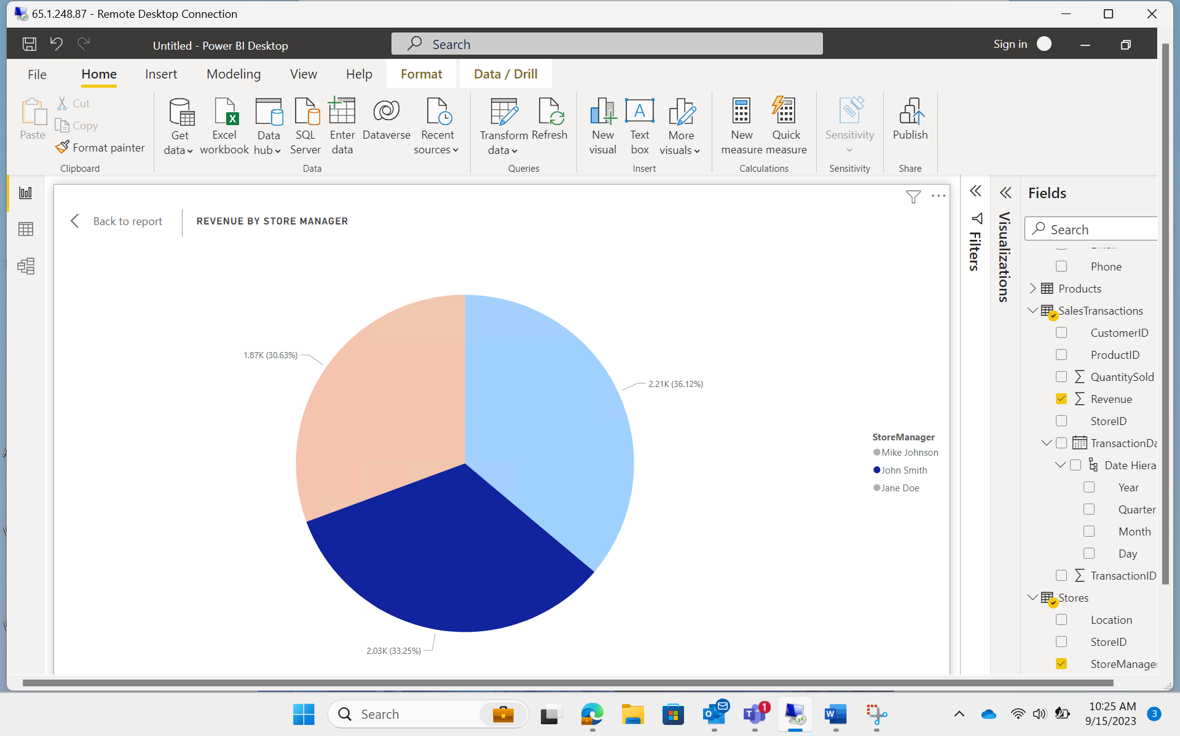

1. What is the average price of products in each category?

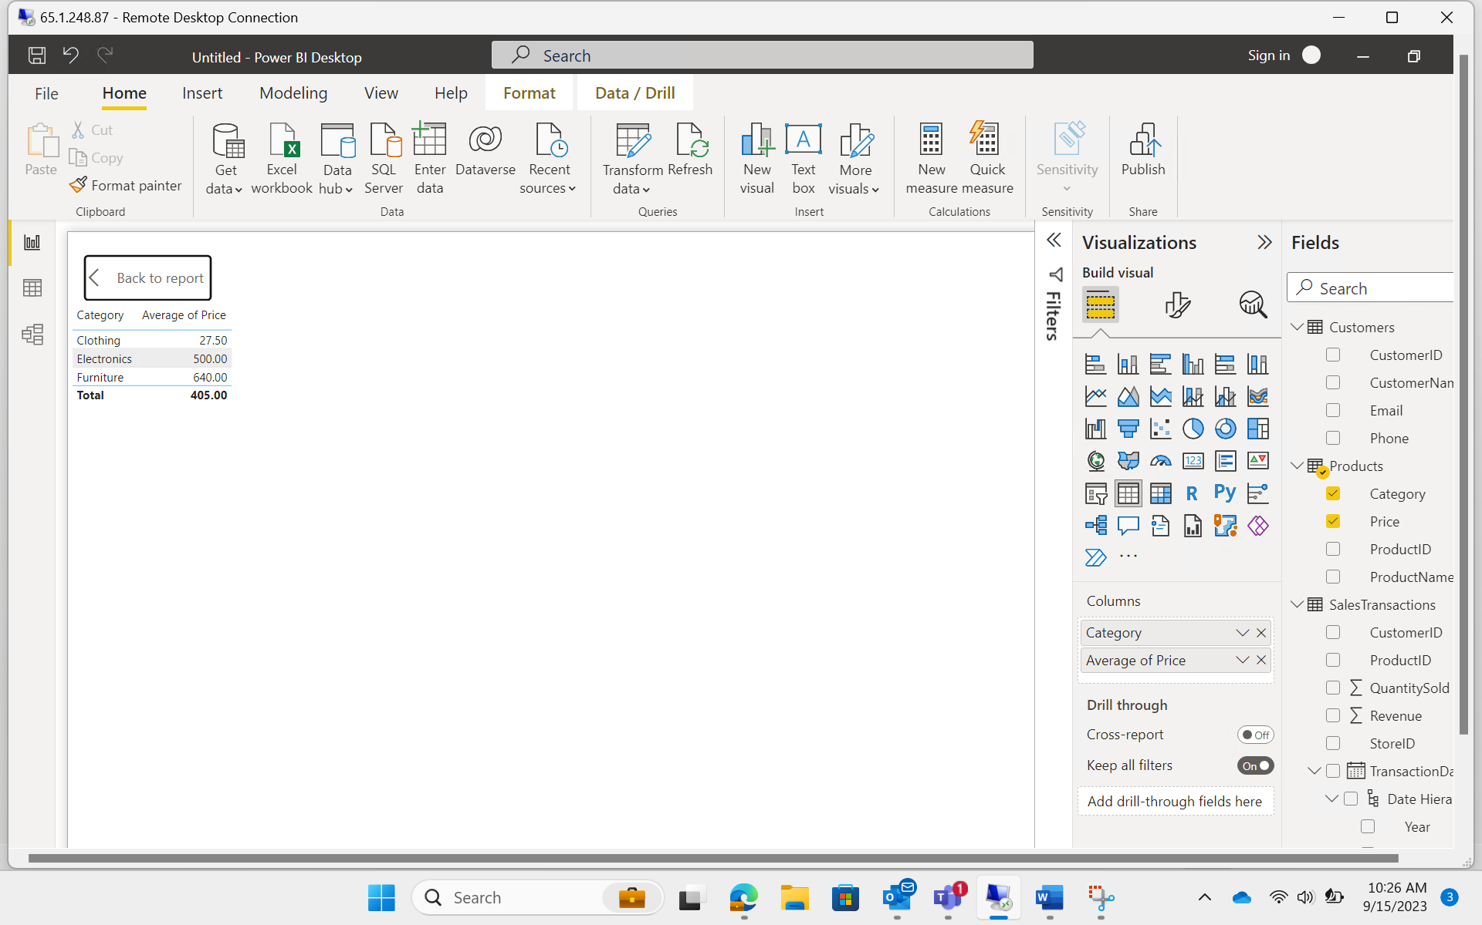

1. Are there specific days of the week when sales are higher?

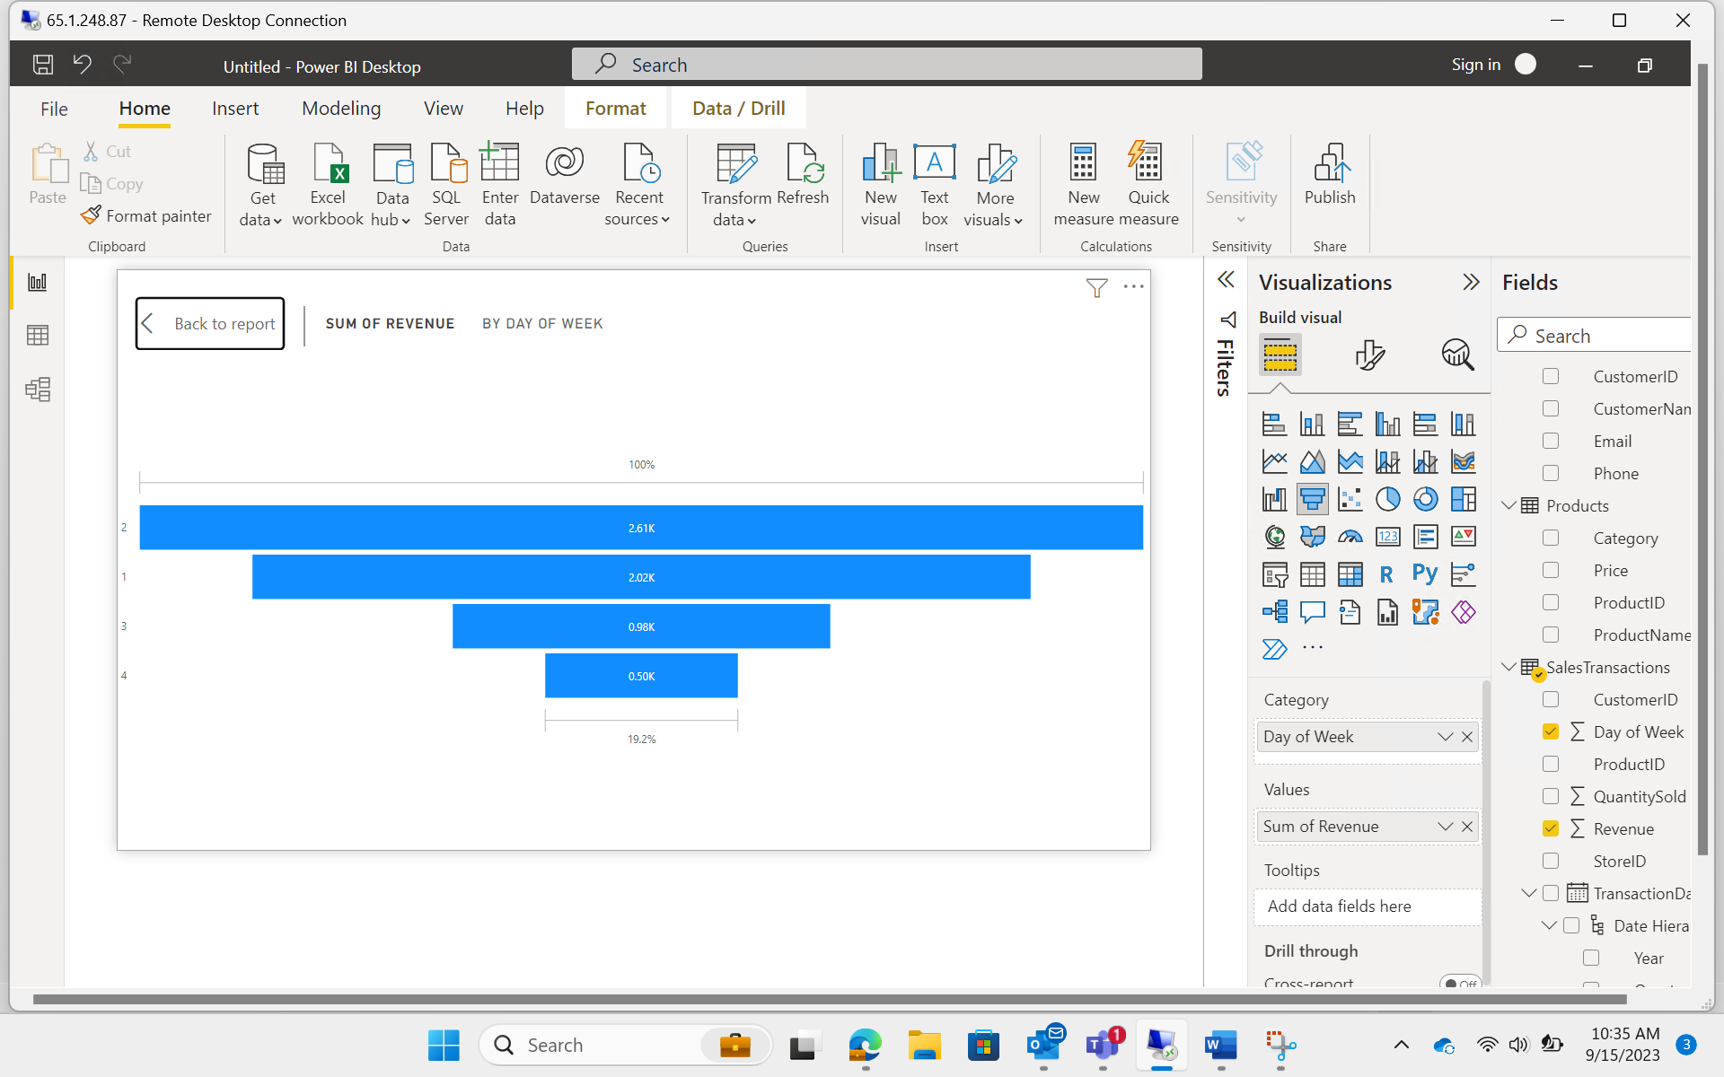

Sales are higher on the second day of the week.

1. How do sales trends vary by product category on a monthly basis?

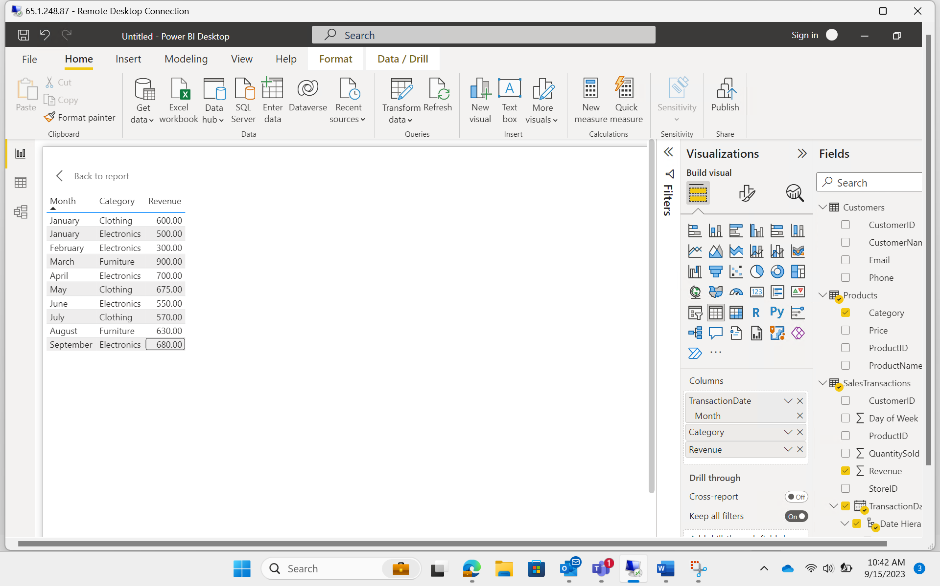

1. What percentage of products account for 80% of total sales revenue?

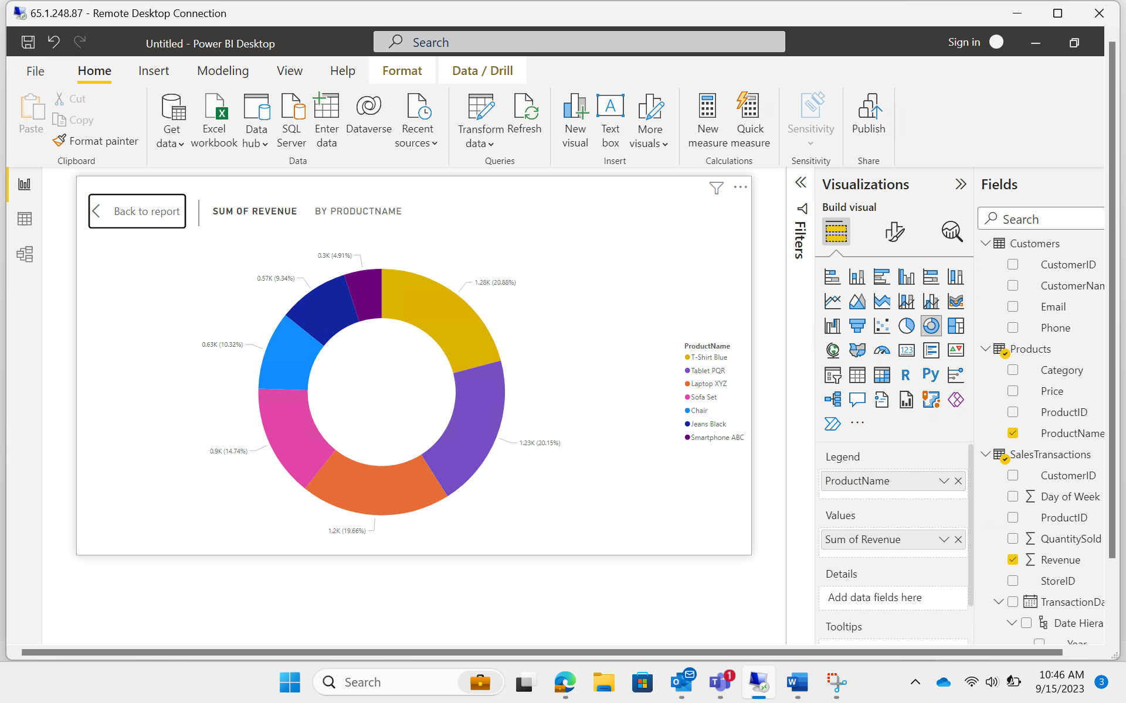

None of the products have sales greater than 80%.

1. Are there any trends in repeat customer purchases?

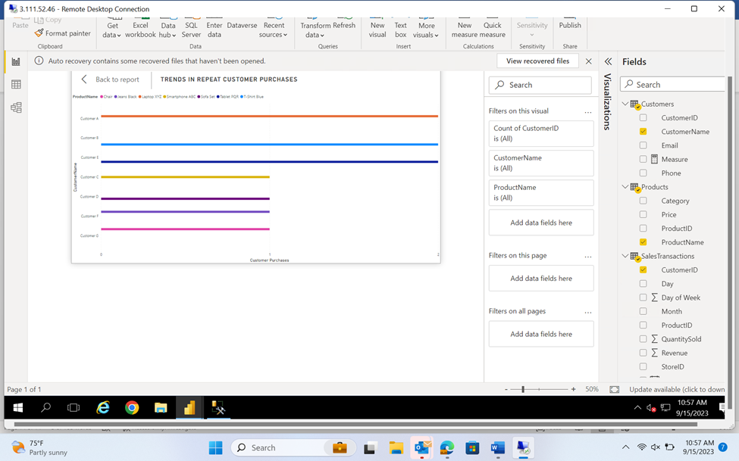

Laptop, Tablet and T Shirt Blue are repeated by same customer.

1. Which product categories perform best at each store location?

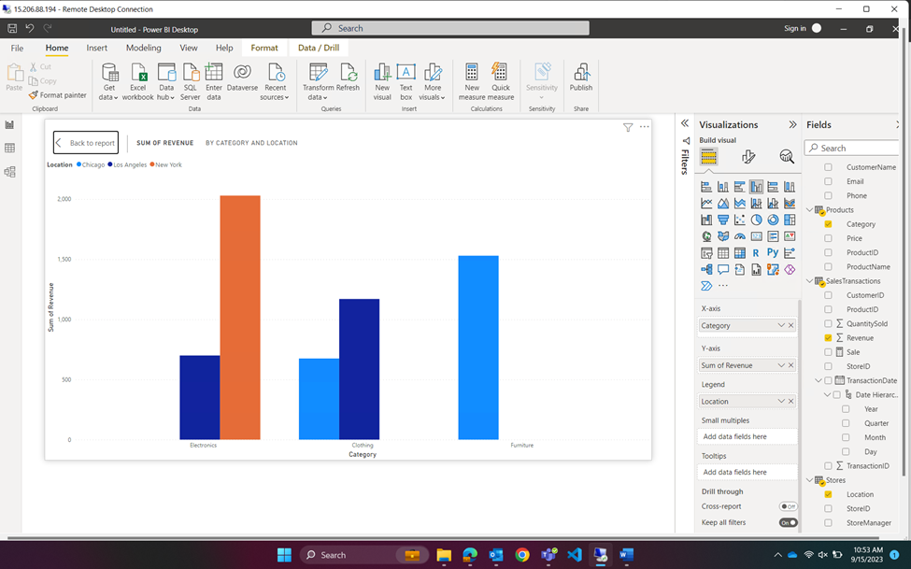

Furniture performs best at Chicago. Clothing at Los Angeles, Electronics in New York.

1. Are there any seasonal patterns or trends in sales for specific products or categories?

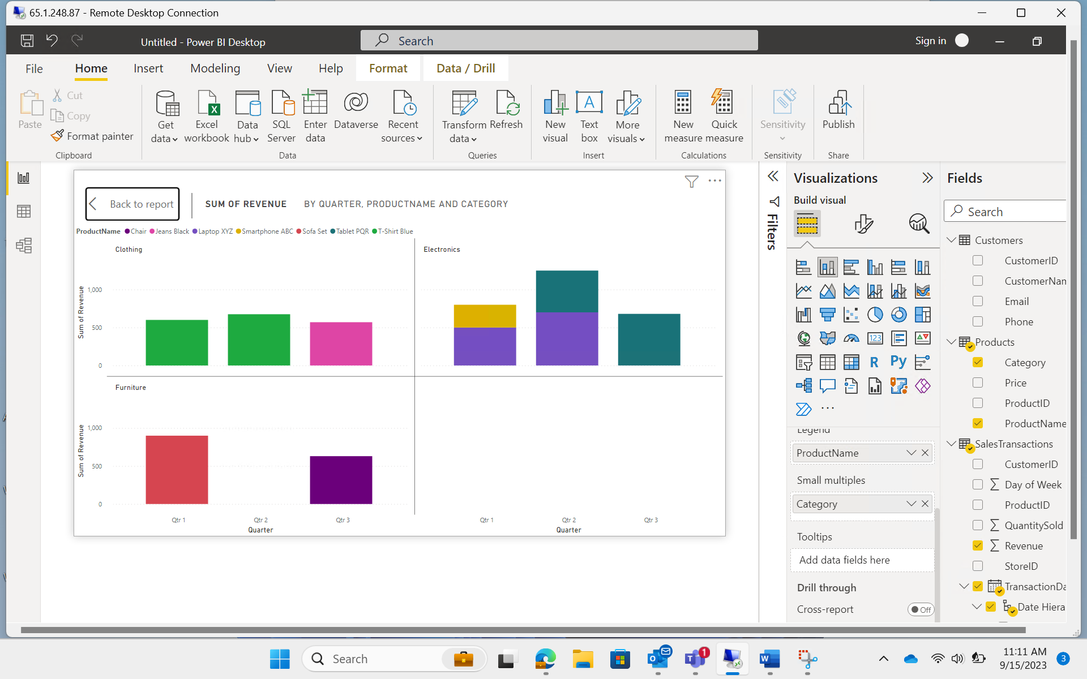

1. Can customers be segmented into high, medium, and low-value segments based on their purchase history.

